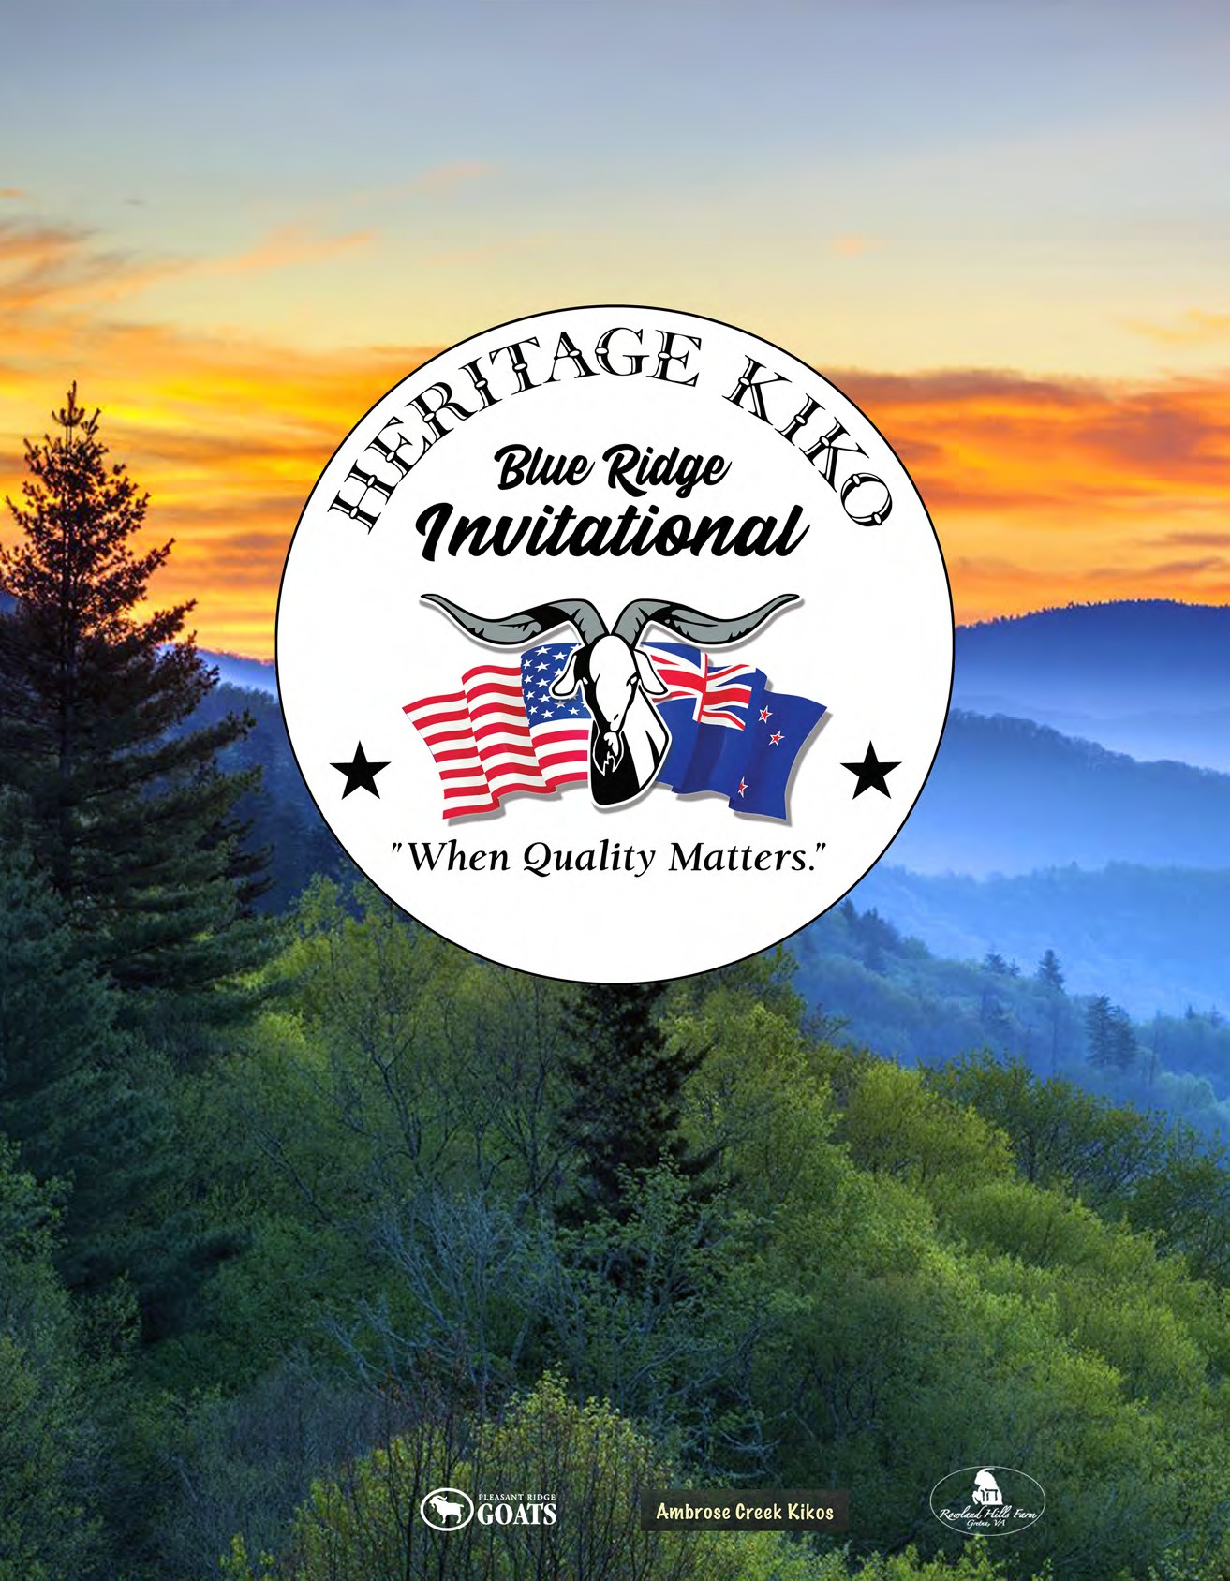

2nd Annual Sale
October 18 & 19, 2021
Greensboro, NC.

Hosted by:

HONCHO’S KEEPER
Son of Goliath's Imprint, aka Boss
FRANK
Son of HVF E66

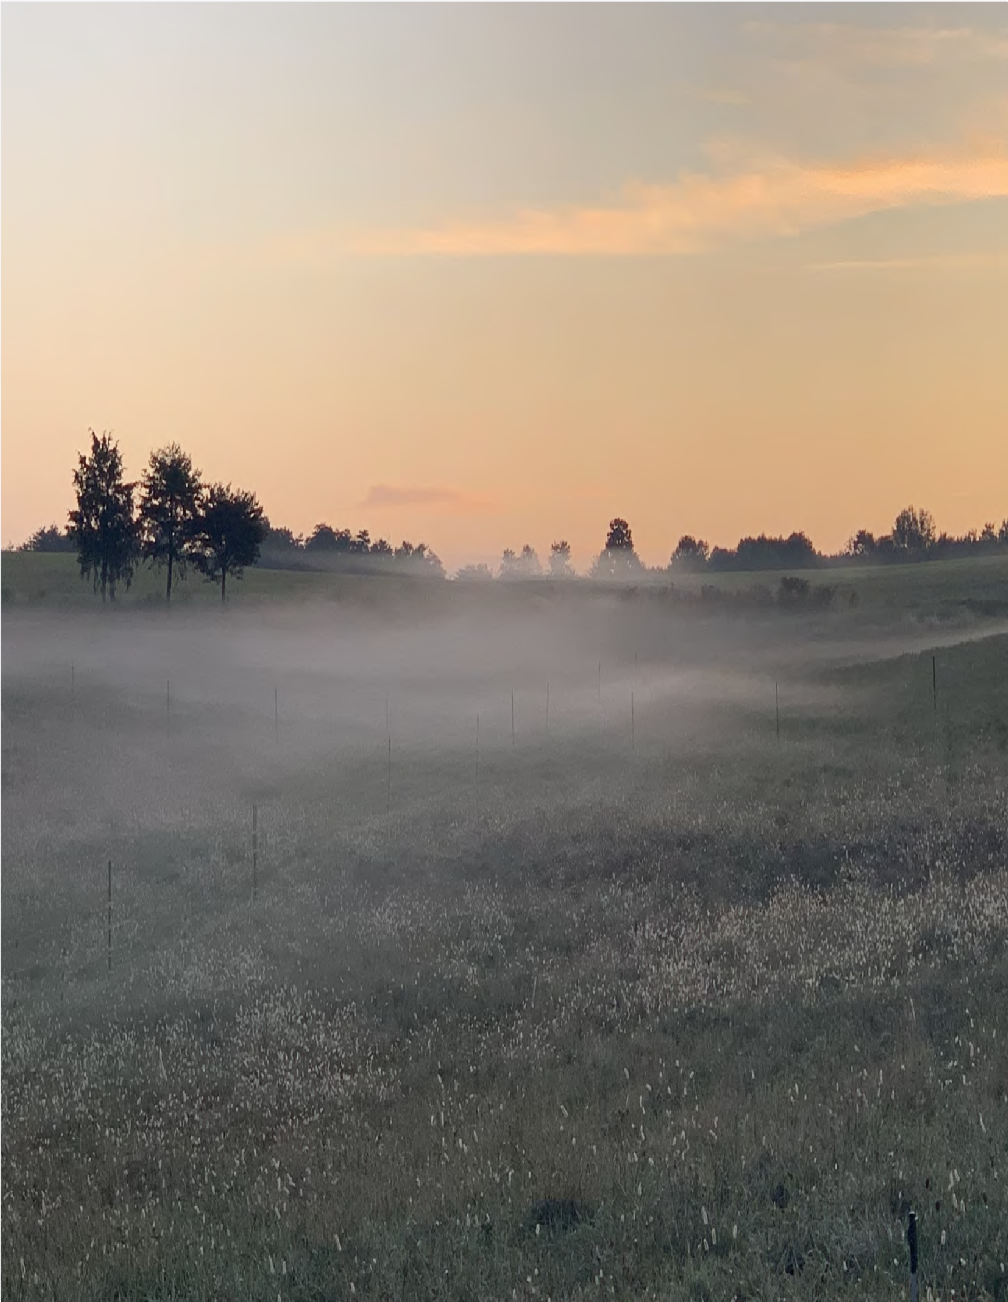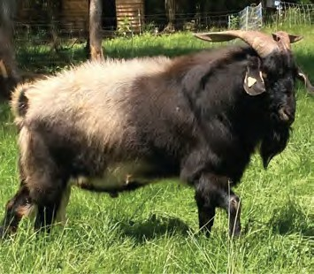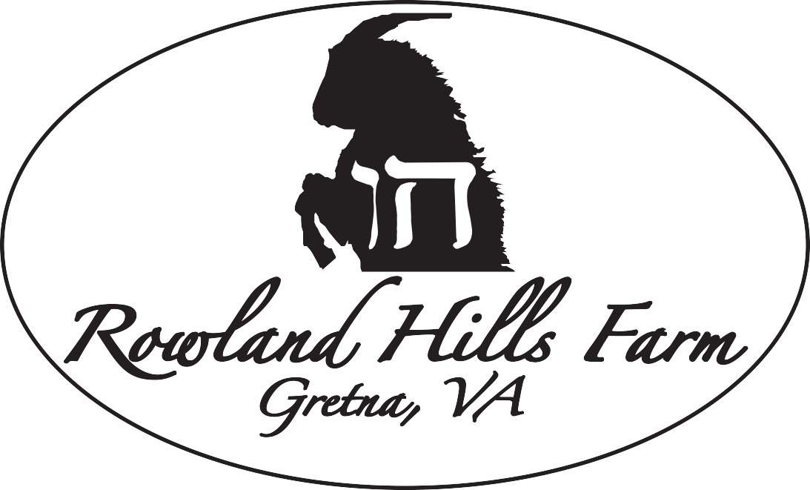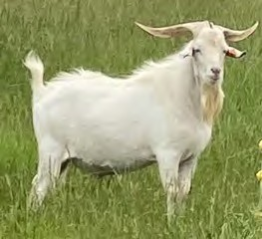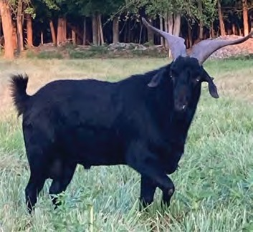
WARSON
Son of Warsaw

Lester & Stefanie Goodman 434-944-5958
rowlandhillsfarm@gmail.com www.rowlandhillsfarm.com

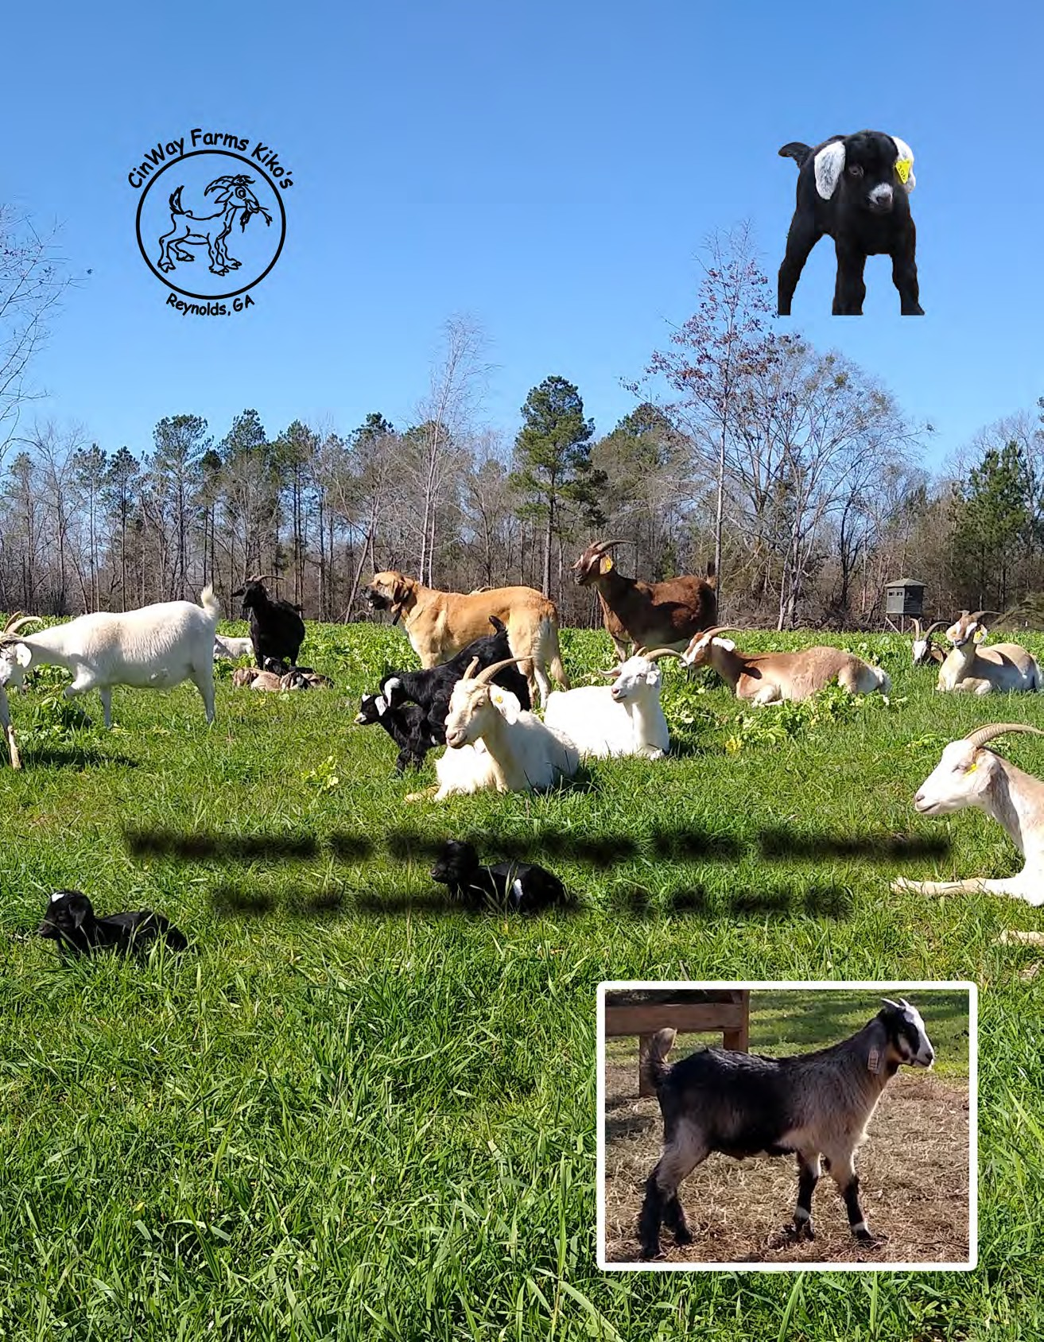

2021 Heritage Blue Ridge Invitational Consignors

JOHN & BARBARA BARNHART
Barnhart Farms (JWB) Wapakoneta, OH john@barnhartgoats.com
GARRY & LINDA CUNNINGHAM
Sho Me Goats (SHO) Campbell, MO shomegoats@yahoo.com
ANDY & PAIGE ROLLER
Warriors Path Kikos (WPK) Kingsport, TN Aroller@warriorspathkikos.com

BRANDON BISHOP
Mystic Hills Farm (MYS) Cumming, GA Brandon.b2130@gmail.com
RANDALL & LEA DANIELS
Somethin bout A Farm (RLD) Siler City, NC Lcmit@aol.com
JOHN P ROLLER
Lazy R Farm (LRF) Kingsport, TN Jpr662@embarqmail.com

FRED BROWN, DVM
Stone Mountain Kikos (SMK) Traphill, NA banimaldoc@wilkes.net

DARRYL OR GAIL BYRD
Gulf South Kikos (GSK) Richton, MS dbyrd142@yahoo.com

JUDY CARTER
Double C Farm (DBC) Brooklyn, MS Iam@judycarters.com

GRANVILLE & MARY CHEATHAM
Nip-n-Tuk Kiko Meat Goats (NNT) Culleoka, TN gjcheatham@gmail.com
WAYNE & CINDY FORSHEE
Cinway Farms (CWF) Reynolds, GA rightsightguy@gmail.com

JOSHUA HEADDEN
Headden’s Kikos (JAH)
Round O, SC j_headden29474@yahoo.com

KENNETH & CONNIE JESSEE
Jessee Farm (KDJ) Castlewood, VA Jesseefarms@gmail.com

DAVID & DEBRA JOHNSON
Windy Hill Farm (WHF) Jackson, TN Et9ddjohnson@gmail.com
MARION L & WANDA D SIMPSON
MWS Farm (MWS)
Asheboro, NC Mwskikos@gmail.com

PHILLIP & LYNN WILBORN
Just Kiddin Caprines (JKC) Langston, AL Uspphil@yahoo.com

JAMES & APRIL WILSON
Circle W Ranch (CWR)
North Tazewell, VA jameswilsonrsh@yahoo.com

LINDA YORK
Sandy Creek Farm (LMY) Ramsuer, NC

Host Farms

TRACY LOYD
Ambrose Creek Kikos (ACK) State Road, NC tracyloyd12@gmail.com
RICH OR LAURA DAVIS
Pleasant Ridge Goats (PRG) Carrollton, GA pleasantridgegoats@gmail.com
LESLEY & STEPHANIE GOODMAN
Rowland Hills Farm Gretna, VA
Rowlandhillsfarm@gmail.com

2021 Blue Ridge Heritage Kiko Showcase Conference

Friday October 15th
1:00 - 1:50 p.m. “Diagnosing and Managing Internal Parasites” Fred Brown DVM Stone Mountain Kikos

2:00 – 3:50 p.m. “Selection for Parasite Resistance in Goats” Andrew Weaver PhD. NC State Small Ruminant Extension Specialist

4:00 - 5:00 p.m. Better Profits with Healthy Goats. Fred Brown DVM Stone Mountain Kikos

LOT 1 ACK TRACY LOYD 100% NZ DOE ACK DARLA
NKR: N21F0141ACK5 TAG: 0141 DNA: PV DOB: 1/19/21
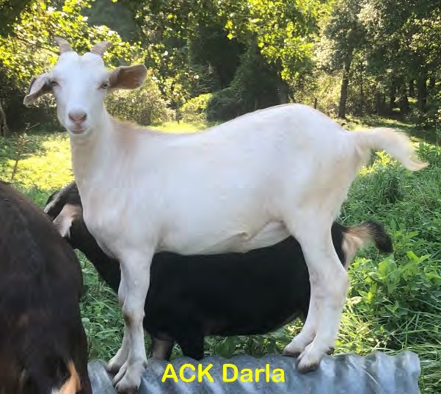
CVK KEEPER’S E116 TMK E142 KEEPER’S SPORT
CLP RAGIN RIVERS DAISY

SIRE: ACK MAGIC MAN
CLP OUTTA THE BLUE

DAM: ACK DIXIE
BMK BLACK MAGIC
SDR ANDREA BEAR
PJF HAMMER’S BIG JAKE PJF SUDDEN IMPACT (SI)
SKY 1108 LINDSEY
GHK WORK ORSE

SMK DAISY
GHK A 34

NOTES: Doeling’s dam and grand dam have great maternals

LOT 2 ROW LESTER & STEPHANIE GOODMAN 100% NZ DOE ROW HONCHO’S BELLA
NKR: N21F0508ROW TAG: 508 DNA: PV DOB: 1/4/21
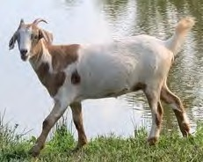
GOATEX GOLIATH WAYSU GOLIATH’S IMPRINT
GOATEX GESTURE

SIRE: OLF HONCHO’S KEEPER
TAY ONYX

PRG ONYX’S LILY
GHK MULAN

HVF 1127 COUNTRY BEAR
DJS COUNTRY GIRL

DAM: ROW SOUTHERN BELL
CVK KEEPERS E116

NOTES: twin
TMK F131 KASSEY
GHK Z08

LOT 3 JWB JOHN & BARBARH BARNHART PB DOE JWB H133C ROSA
NKR: N18F0133JWB4 TAG: H133C DNA: PV DOB: 7/2/18
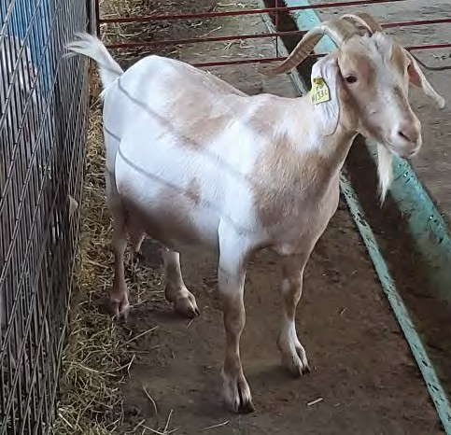
WAYSU GOLIATH’S KEEPER CVK KEEPERS E116
AVG JUNE

SIRE: JWB PAINTED WARRIOR
TMK D59
GHK APACHE LOVERBOY GAL CHAMPAIGN
BWP SPECKLE’S PATCHES F0877

LOO PATCHE’S MUG SHOT
LOO FLAME’S SUNFLOWER

DAM: LOO MUG SHOT’S 3012
GFI ROLLING MEADOW’S 81

BWP SPECKLES 301 GIRL
GFI ROLLING MEADOWS 232
NOTES: Triplet, proven mother

LOT 4 NNT GRANVILLE & MARY CHEATHAM 100% NZ DOE NNT K2038
NKR: N20F2038NNT7 TAG: K2038 DNA: PV DOB: 3/7/2020
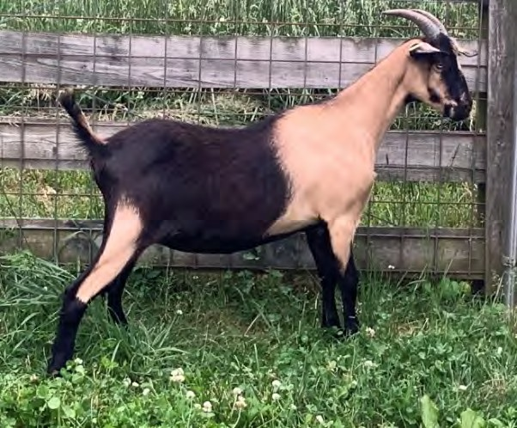
TAY ONYX BBM ONYX BEAR
BBM NICKOLE W956

SIRE: SDR PIERS BEAR

ECR PETUNIA
ECR RUSTY ECR GLORIA
SKY S408 SPORTS KAT

DAM: NNT D249
ECR ALEXANDER
ECR GLORIA
SDR PIERS BEAR

NNT’S B146
NNT’S X3
NOTES: Dual registered with the AKGA, CD&T vaccinated, tested negative for CAE & Johnes'

LOT 5 LRF JOHN ROLLER 100% NZ DOE LRF 1622’S BAY GIRL
NKR: N20F0119LRF0 TAG: 0119 DNA: PV DOB: 1/1/20
SKY W018 WARSAW HKF SONNY BOY
HKF SARA RUTH

SIRE: SAN SONNY BOY’S 1622
GIN V2C

TLF TOP GUN
TNT CODY
OAK VALLEY 0053 JFK NOBLE
TLF GERANIUM

DAM: LRF GLORIA

NOTES:

WMB EMILY
CCR SAZERAC JFK AMBER 2

LOT 6 PRG RICH OR LAURA DAVIS 100% NZ DOE PRG MOJO’S ELLEN
NKR: N19F0025PRG2 TAG: J25 DNA: PV DOB: 1/12/19
BETULA HILL MONEYMAKER SUNBOY 117 LOVERBOY
SEVENTREES SANDALWOOD

SIRE: PRG LOVERBOY’S MOJO JOJO
GHK SARABI
COO IRON HORSE
AKR LIGHTIN’S LADY N13 BBM ONYX BEAR

SDR NANOOK ONYX BEAR
SDR LOUISE BEAR

DAM: SDR ELIZABETH BEAR
SKY S408 SPORTS KAT

NOTES:
BBM SPORTS KAT V917
TLF ETOSHA

LOT 7 LMY LINDA YORK 100% NZ DOE LMY MISS GEMMIE
NKR: N20F0204LMY2 TAG: 0204 DNA: PV DOB: 9/6/20
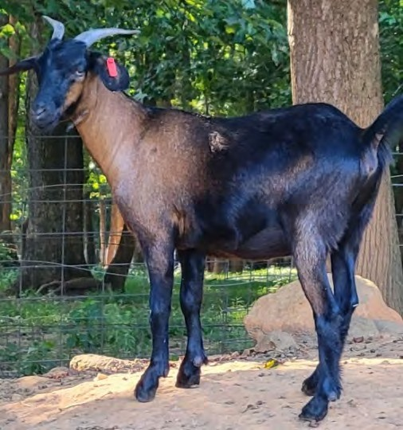
CAPRINEX SAMUEL HESLINGTON SESAME
*4K984CPR

SIRE: SDR POSIDEON SESAME BEAR
BBM ONYX BEAR

SDR ROSEMARY BEAR
BBM SPORT’S KAT RILEY

BBM NICK’S X232 GNX WILBUR’S BUD
GHK LOUISIANNA

DAM: QRR WIL’S WILMA
TOF GEMMIE
NOTES:
HKF GEORGE HKF MEG

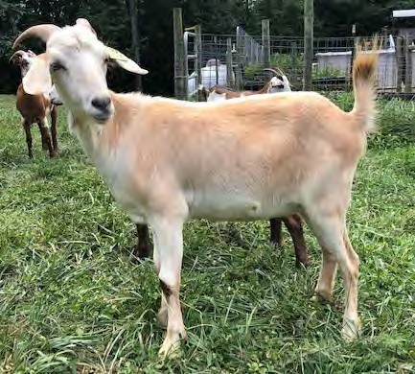LOT 8 MYS MYSTIC HILLS KIKOS 100% NZ DOE MYS MYSTIC DAISY
NKR: N20F0009MYS6 TAG: 9 DNA: PV DOB: 1/25/20
ECR RUSTY
CGI SPITFIRE
SIRE: CGI DEUCE
CGI ESTHER
HRK PANGO’S SUMMER BREEZE
LRF PANGO HUA
CGI BARON’S DELIGHT
DAM: OLF LODI
ECR RUSTY ECR RUSTY’S RAMBO
ECR HANKY PANKY
ECR RUSTY
ECR SUNNY
ECR M4
NOTES:

LOT 9 KDJ KENNETH & CONNIE JESSEE 100% NZ DOE KDJ TOMAHAWK’S BERRY
NKR: N20F2014KDJ9 TAG: 2014 DNA: PV DOB: 1/1/2020
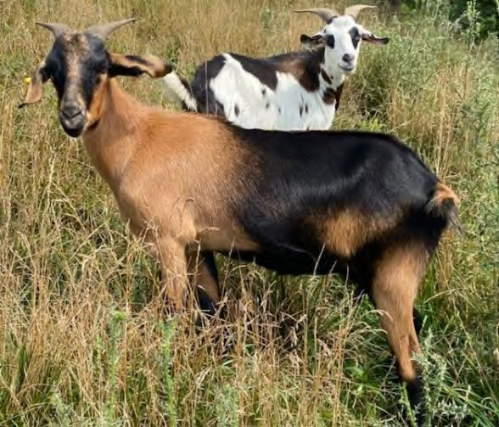
HKF SONNY BOY

MRG OUTLAW
HKF SAPHIRE

SIRE: LFK H809 OUTLAW’S TOMAHAWK
COO IRON HORSE

GHK A 59
GHK Y51
SDR NANOOK ONYX BEAR

SDR BEAUREGARD BEAR
SDR BLACKBERRY BEAR
DAM: KDJ REDNECK’S BERRY BEAR
ECR RUSTY
AFK REDNECK WOMAN
HKR PANGO’S SUMMER BREEZE
NOTES: Tomahawk’s Berry is out of a daughter of Redneck Woman

LOT 10 PRG RICH OR LAURA DAVIS PB DOE PRG K212
NKR: N20F0212PRG5 TAG: K212 DNA: PV DOB: 11/20/20
LFK OUTLAW’S RENEGADE YFK RENEGADE’S STORMY
HKF LITTLE JOE’S JOSEPHINE

SIRE: SAF SPRINGS DIEGO
TMK MACHO’S BLACK GUY

SAF SPRINGS CALICO PATCH
TJR SUNSHINE

KMG MARKSMAN

DAM: CFP HEATHER

NOTES:
JDR OLIVER

JDR HILLARY
KMG ASTRA
BBM NICK’S W948 JDR JAZY’S GIRL

LOT 11 MWS MARION L & WANDA D SIMPSON 100% NZ DOE MWS NICOLE
NKR: N18F0276MWS3 TAG: 0276 DNA: PV DOB:2/18/2018
GOATEX GENERATOR GHK HIGH VOLTAGE
MRG LIGHTIN’S LADY R06

SIRE: AAA REGULATOR
WAYSU GOLIATH’S KEEPER

GFI ROLLING MEADOWS 198
GFI CONFEDERATE/ZORRO 19

AKR LIGHTIN’S TITAN N06 MRG TITAN’S HAMMER
AKR LIGHTIN’S LADY N08

DAM: GAL SAMANTHA
JFK ELLY

NOTES: Has Regulator’s Blue Eyes
TASMAN ARISTOCRAT WAYSU’S GOLIATH’S ELEGANCE

LOT 12 DBC JUDY CARTER 100% NZ DOE DBC GRANNY’S GIRL
NKR: N17F0102DBC3 TAG: 102 DNA: PV DOB: 12/29/17
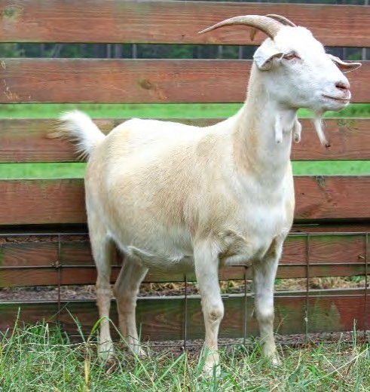
ECR RUSTY

SIRE: CGI DEUCE
CGI SPITFIRE

CGI ESTHER
HRK PANGO’S SUMMER BREEZE LRF PANGO HUA
CGI BARON’S DELIGHT
ROLLING HILLS FRANK

BOULDER HILL’S BRICK
BHF TRACY

DAM: FRF FLETCHER FARM’S V50
FRF 13

NOTES:
HBK 119
HBK 143

LOT 13 NNT GRANVILLE & MARY CHEATHAM 100% NZ DOE NNT K2048
NKR: N20F2048NNT8 TAG: K2048 DNA: PV DOB: 3/8/2020
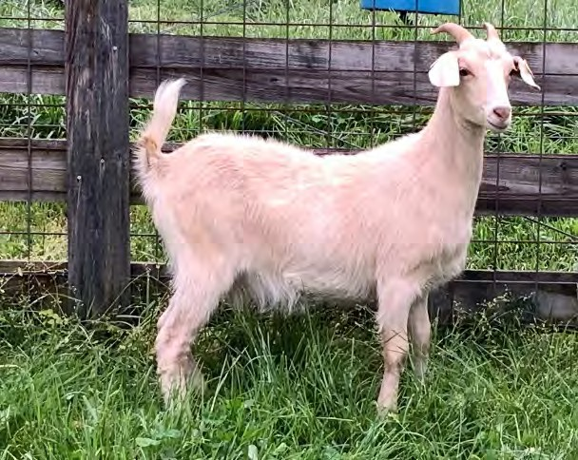
HKF SONNY BOY SAN SONNY’S TASMAN TRICKS
GAL AERIAL

SIRE: PJM PADDINGTON
CPK ROOSTER COGBURN

PJM ROOSTER/COPYRIGHT G39
PJM COPYRIGHT/CODY SON 50

TLF TOP GUN

DAM: NNT F622

NOTES:
LCK REDMAN

NNT D253
ECR VICTORIA’S SECRET ECR ALEXANDER
NNT’S BW158

LOT 14 MYS MYSTIC HILLS KIKOS 100% NZ BUCK CGI VAQUERO
NKR: N14M0557CGI8 TAG: 0557 DNA: PV DOB: 3/24/14
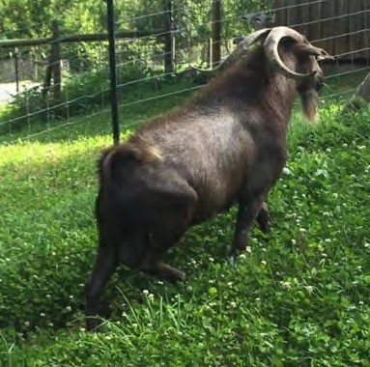
BHF TOP NOTCH CHAMPAGNE CGI RHETT 507
CGI LEIA 504

SIRE: CGI SHOGUN

ECR CONDI
SUNBOY STANTON 149 ECR GLORIA
SUNBOY WACO 139

AKR LIGHTIN’S TITAN
VICTORIA FARM PUDDIN’

DAM: CGI TITAN’S LEIA
CGI LEIA 504
NOTES:
LRF PANGO HUA
JFK SERENITY’S BEST

LOT 15 PRG RICH OR LAURA DAVIS 100% NZ BUCK TAY ONYX
NKR: N00M0029TAY2 TAG: DOB: 4/4/00 TWO STRAWS OF FROZEN SEMEN
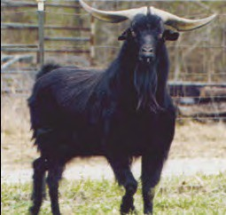
HESLINGTON SESAME GOATEX THE PHANTOM
GOATEX GRECHEN

SIRE: TASMAN ZORRO

BARDON GIGOLO BARDON BARDELLI
BARDON 62/84
BETULA HILL BOUNCER BETULA HILL MONEYMAKER
BARDON 62/84

DAM: CCR MISS LIBERTY
JTV THERESA
NOTES: Stored at B&D Genetics
GOATEX CONFEDERATE GOATEX CAPRICE

LOT 16 ROW LESTER & STEPHANIE GOODMAN 100% NZ BUCK ECR RUSTY’S RAMBO
NKR: N10M0100ECR0 TAG: DOB: 1/20/10 TWO STRAWS OF FROZEN SEMEN
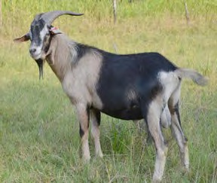
GOATEX TERMINATOR SOUTHWEST CISCO
GOATEX GEMSTONE

SIRE: ECR RUSTY

JTV NINA
JTV KLONDIKE JTV BLUE BELLE
BETULA HILL MONEYMAKER

SUNBOY STANTON 149
SUNKIST #21

DAM: ECR HANKY PANKY
JTV QUEEN
NOTES:
JTV KLONDIKE JTV JAZZMINT

LOT 17 JKC PHILLIP & LYNN WILBORN 100% NZ BUCK JKC SW MAVERICK
NKR: N19M0042JKC2 TAG: J42 DNA: PV DOB: 4/4/2019
GOATEX TERMINATOR SOUTHWEST CISCO
GOATEX GEMSTONE

SIRE: ECR RUSTY

DAM: JKC GENET

NOTES:

JTV NINA TLF DEX JKC NICE
JTV KLONDIKE JTV BLUE BELLE TLF LEGEND TLF NYX
TLF LEGEND TLF NETTA

LOT 18 CWF WAYNE & CINDY FORSHEE 100% NZ DOE CWF OPHELIA
NKR: N20F0108CWF5 TAG: 108 DNA: PV DOB: 1/15/2020
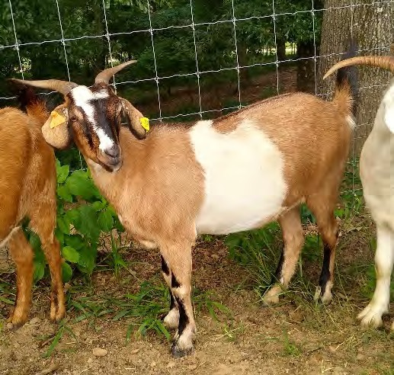
LRF PANGO HUA
WMB HOBO
ECR CONDI
SIRE: HKF HOBO’S PRIDE
CPK LITTLE JOE
HKF TRIG’S GIRL
HKF TRIG

WMB MINGO AVG’S OZARK APACHE
AVG’S OZARK BUMPKIN

DAM: PRG MEMPHIS BELLE
SAF SPRING’S MERLIN

SAF SPRING’S FOXY GIRL 425
LGB HONEY’S FOXY Y012
NOTES: Vaccinated CDT and CL, confirmed bred to Outlaw's Flash.

LOT 19 DBC JUDY CARTER 100% NZ DOE DBC DOUBLE C’S MISS MOLLY
NKR: N18FF0111DBC4 TAG: 111 DNA: PV DOB: 3/1/18
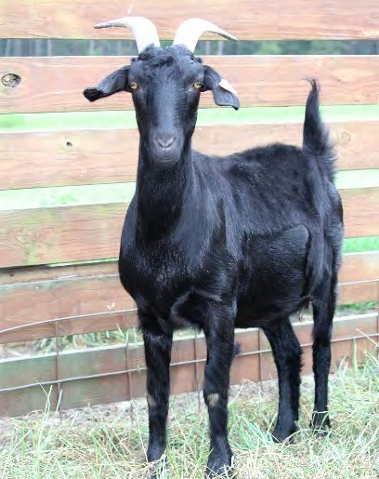
SOUTHWEST GOLDMINE’S ROCKER LRF PANGO HUA
TASMAN TOIA

SIRE: OLF SCRATCH

DAM: SMK ZENA

GOATEX GENERATOR SDR GINA GENERATOR BEAR
SDR ALICE BEAR
ECR RUSTY ECR ROHO GRANDE’
ECR P77
GHK JACK FLASH

NOTES:
GHK Z32
GHK LITTLE BLACKIE

LOT 20 NNT GRANVILLE & MARY CHEATHAM 100% NZ DOE NNT K2050
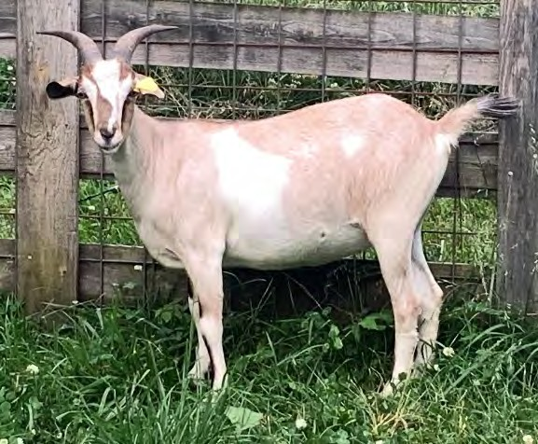
NKR: N20F2050NNT7 TAG: K2050 DNA: PV DOB: 3/8/2020
SOUTHWEST SPORTSMAN SKY S408 SPORTS KAT
TASMAN TEMPTRESS

SIRE: CLP RAGIN RIVER’S HITMAN
TSF ZOLO’S R090

DAM: NNT F629
TSF ZOLO’S R479
ECR RED NELLE
BBM ONYX BEAR SDR PIERS BEAR
ECR PETUNIA
MMG MIDDLEBROOK MAGIC

NNT’S Z4
NNT’S X2

NOTES: Dual registered with the AKGA, CD&T vaccinated, tested negative for CAE & Johnes'

LOT 21 WHF DAVID & DEBRA JOHNSON 100% NZ DOE WHK K46
NKR: N20F0046WHF8 TAG: K46 DNA: PV DOB: 3/3/2020
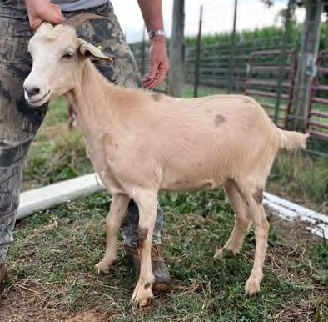
ELH BLUE BOY 1L BLUE’S SON
ELH 7L

SIRE: GHK SILVER BULLET
GHK CA19
COO IRON HORSE BOULDER HILL’S SR96
TAY ONYX

DAM: WHF G14
GHK WINDY HILL ONYX STAR
GHK LITTLE BLACKIE
TSF ZOLO’S R090 TSF ZOLO’S R480
ECR RED NELLE

NOTES: WHF K46 is exposed to WHF J29 SMOKY JOE

LOT 22 PRG RICH OR LAURA DAVIS 100% NZ DOE PRG BUBBLES
NKR: N20F006PRG TAG: K065 DNA: PV DOB: 2/21/20
ELH BLUE BOY 1L
BLUE’S SON
ELH 7L
SIRE: CLP PALE RIDER
BBM ONYX BEAR
SDR DENNA BEAR
SDR DANITA BEAR

- JFK DELILAH’S
JFK PEPPY
JFK LENNA
DAM: BWP PEPPY’S SPRINKLES 577
TNT’S RAIZ’N’KANE

NOTES:
BWP KANES 46 GIRL
JFK DARLING’S ONLY

LOT 23 JKC PHILLIP & LYNN WILBORN 100% NZ DOE JKC RUSTY MOON
NKR: N19F0040JKC4 TAG: J40 DNA: PV DOB: 4/4/2019
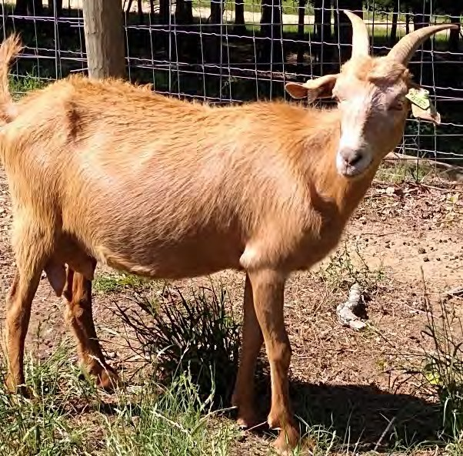
GOATEX TERMINATOR SOUTHWEST CISCO
GOATEX GEMSTONE

SIRE: ECR RUSTY

DAM: JKC GENET

JTV NINA

TLF DEX
JTV KLONDIKE JTV BLUE BELLE

TLF LEGEND TLF NYX

JKC NICE

TLF NETTA

NOTES: Vaccinated CDT and CL, confirmed bred to Outlaw's Flash.

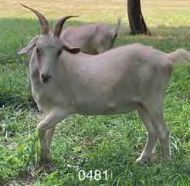LOT 24 ROW LESTER & STEPHANIE GOODMAN 100% NZ DOE ROW HONCHO’S RIVER
NKR: N20F0481ROW4
TAG: 0481
DNA: PV
DOB: 2/13/20
GOATEX GOLIATH WAYSU GOLIATH’S IMPRINT
GOATEX GESTURE
SIRE: OLF HONCHO’S KEEPER
TAY ONYX PRG ONYX’S LILY
GHK MULAN
ECR RUSTY
CGI SPITFIRE
HRK PANGO’S SUMMER BREEZE
DAM: CWR SPITFIRE’S RIVER QUEEN
GHK ISAIAH’S FIRE RDH PROUD MARY
AFS ROHO’S DIANA
NOTES:

LOT 25 LRF JOHN ROLLER 100% NZ DOE LRF 1622’S OGO EMMA
NKR: N20F0129LRF1 TAG: 0129 DNA: PV DOB: 1/12/20
SKY W018 WARSAW HKF SONNY BOY
HKF SARA RUTH

SIRE: SAN SONNY BOY’S 1622
GIN V2C
TNT CODY
OAK VALLEY 0053 MRG OUTLAW

RDH OUTLAW’S GOLDMINE
TSF LITA’S GIRL

DAM: LRF OUTLAW’S LADY
LRF GLORIA
NOTES:
TLF TOP GUN WMB EMILY

LOT 26 ACK TRACY LOYD 100% NZ DOE ACK LARUE
NKR: N20F0098ACK1 TAG: 0098 DNA: PV DOB: 1/2/20
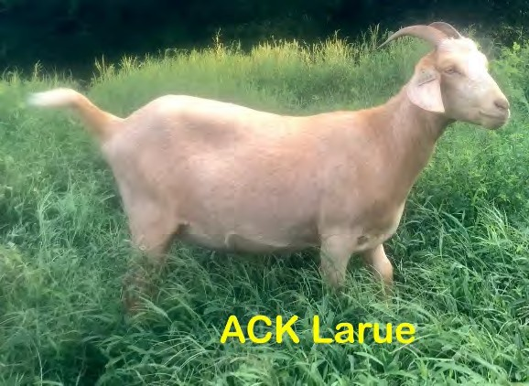
GFI WILD BILL

GNX ACE
SIRE: GNX ROSCOE KIKOTRAIN
BOULDER HILLS WR179 COO IRON HORSE

DAM: SMK RUBY NOTES:
GHK LOUISIANNA
TAY W.48
COO IRON HORSE GHK WORK HORSE
DSL’S BLUE’S GIRL 81
SUNBOY 117 LOVERBOY GFI ROLLING MEADOWS 341
JAK JAMILLA 2

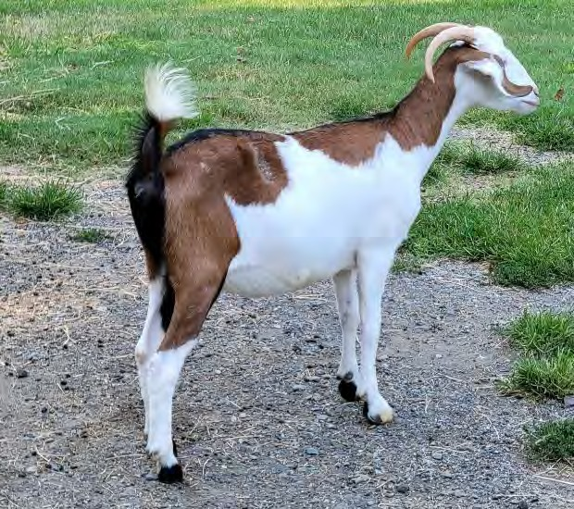LOT 27 LMY LINDA YORK 100% NZ DOE LMY VENUS’S COOL MAGGIE
NKR: N20F0190LMY2
TAG: 0190
DNA: PV
DOB: 2/8/20
BLUE’S SON PRG VENUS’S COOL BLU
GHK VENUS
SIRE: LMY VENUS’S MAXAMILLION
GHK IRON MAVERICK JJS JERSEY GIRL
JEL ACHALBELLA
BLUE’S SON PRG VENUS’S COOL BLU
GHK VENUS
DAM: JJS MARGARET’S PLUM
RLP PEACOCK’S RED ROVER RLP PEACOCK’S MARGARET’S MANGO
RLP MARGARET

NOTES:

LOT 28 GSK DARRYL BYRD 100% NZ DOE GSK OUT OF THE CLEAR BLUE
NKR: N20F0664GSK TAG: 0664 DNA: PV DOB: 2/29/20
SLR TERMINATOR’S XX GEL TERMINATOR’S XXX
GFI ROLLING MEADOWS 68 BLAZE

SIRE: TMK BLUE KNIGHT
RAK EVE

MJI FRANKIE
ELH BLUE’S SON
BO PEEP ACRES 0037 MGR TITANS RC
AVG BONNIE

DAM: SLS RAINEY

NOTES:

PSF RAE RAE
GHK HIGH VOLTAGE SLS RUTH

LOT 29 NNT GRANVILLE & MARY CHEATHAM 100% NZ DOE NNT K2054
NKR: N20F2054NNT3 TAG: K2054 DNA: PV DOB: 3/8/20
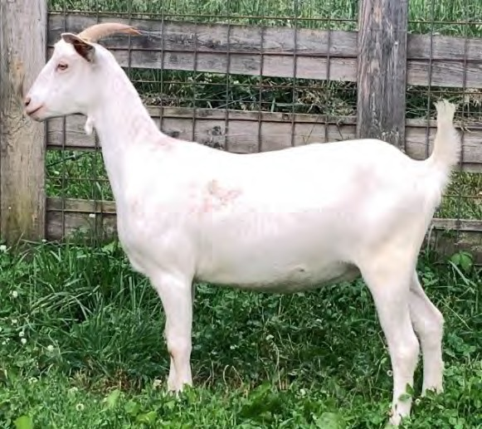
HKF SONNY BOY SAN SONNY’S TASMAN TRICKS
GAL AERIAL

SIRE: PJM PADDINGTON
CPK ROOSTER COGBURN

PJM ROOSTER/COPYRIGHT G39
PJM COPYRIGHT/CODY SON 50

TLF TOP GUN

DAM: NNT H1874

NOTES:
LCK REDMAN

NNT F609
ECR VICTORIA’S SECRET ECR ALEXANDER
BBM SPORTS KAT V890

LOT 30 ROW LESTER & STEPHANIE GOODMAN 100% NZ DOE ROW ROXI
NKR: N21F0502ROW TAG: 0502 DNA: PV DOB: 1/4/2021
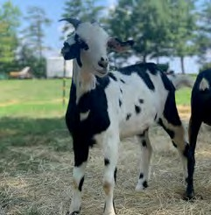
CAPRINEX 11/85 GOATEX 62/89
GOATEX 614/86

SIRE: OLF ROCKY

SKY 215 XCLUSIVELY BLUE GSK ALEXIS BLUE
HKF ANNIE
COO IRON HORSE GHK ISAIAH’S FIRE
SKY W717 WYNENA

DAM: RDK ISAIAH’S AVA
TLF TOP GUN

NOTES:
LCK VICTORIA’S BABY
ECR VICTORIA’S SECRET

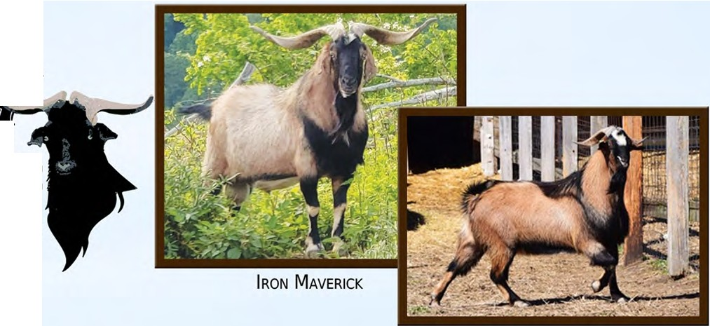
t>•c _,.
tj '

BAllt:11

Tazewell, VA 276-701-5626

DD.&.An&, ,
.LL&l.a AlfJ deanhillkikos.com

ffn

T V ...

,o·s

ZEUS STING BEAR

Pleasant Shade, TN • 615-388-3774

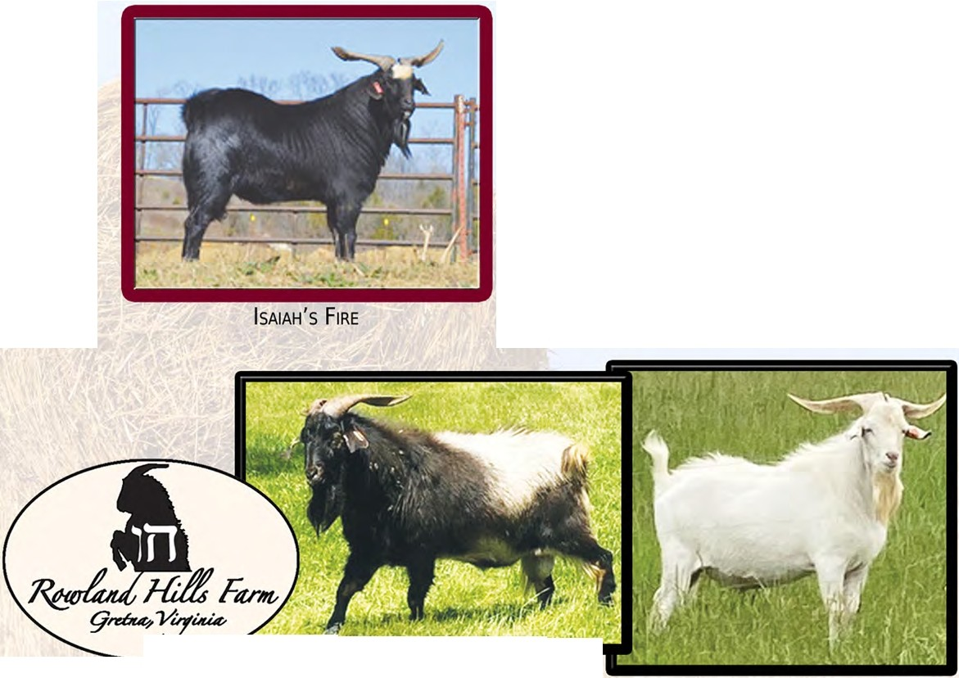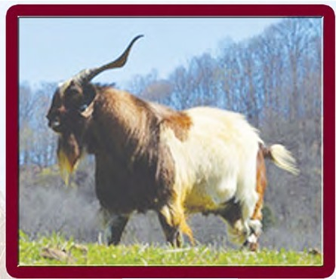rowlandhillsfarm.com 434-944-5958
INDIAN OUTLAW
.
?
·._....._llllllii
llllf!I
HONCHO

KIKOS U ITEC,1 LC.
www.kikosunited.com

With a common desire to promote and affirm this exceptional breed, Circle W Ranch, Dean Hill Kikos, and Rowland Hills Farm have established Kikos United, LLC. It is our goal to combine our knowledge, our established breeding programs and our love for the industry to serve the kiko community. While our focus will always be to build better kikos, we will also be providing ongoing educational and sales opportunities along with transportation options.

Our individual farms will continue our normal operations and offer the same quality and service as before. Kikos United, LLC will give us the tools to work together to serve a stronger and united kiko community.

UNITED: in working to educate and support new breeders. UNITED: in building a strong foundation for the future of kiko goats. UNITED: in the goal of providing quality breed stock.
UNITED: in our desire to establish strong working relationships.

CONTACT Us

615-774-3663
kikosunited@gmail.com

LOT 31 JWB JOHN & BARBARA BARNHART PB DOE JWB J332 JEMS
NKR: N19F0332JWB0 TAG: J332 DNA: PV DOB: 12/27/19
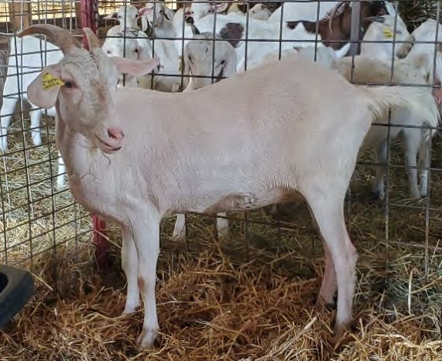COO IRON HORSE GHK BROADWAY JOE
TASMAN TOIA

SIRE: JWB BLACK JACK

CLP RAGIN RIVERS BIG KAT CLP RAGIN RIVERS EARTHA
SDR ROSA BEAR
CVK KEEPERS E116 JWB PAINTED WARRIOR
TMK D59

DAM: JWB H138C VIOLET
LOO PATCHE’S MUG SHOT

LOO MUG SHOT’S 2881
BWP BIG MACK’S 288 GIRL
NOTES: proven mother
LOT 32 SMK FRED BROWN DVM 100% NZ BUCK TLF LEGEND
NKR: N06M0001TLF9 DOB: 3/19/06 Two Frozen Semen straws
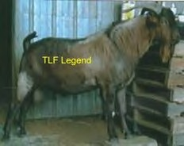
BETULA HILL BOUNCER BETULA HILL MONEYMAKER
BARDON 62/84

SIRE: SUNBOY STANTON 149
SUNKIST #21
GOATEX GENERATOR
SEVENTREES SANDALWOOD GOATEX GOLDMINE

AAS GOLDMINE IV
BETULA HILL BRIMSTONE
DAM: WAYSU GOLDMINE’S ESTHER
GOATEX GOLIATH
AAS ASPINELLE 2
GOATEX ASPINELLE
NOTES: Semen straws will be available day of sale for transfer or new owner responsible for transfer

LOT 33 PRG RICH OR LAURA DAVIS 100% NZ BUCK BLUE’S SON
NKR: N02M0083ELH4 TAG: DOB: 1/10/02 TWO STRAWS OF FROZEN SEMEN
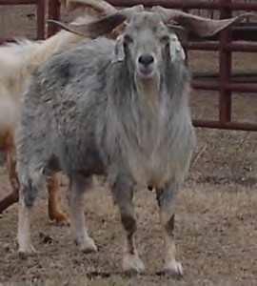
BETULA HILL MONEYMAKER SUNBOY STANTON 149
SUNKIST #21

SIRE: ELH BLUE BOY 1L
BETULA HILL MONEYMAKER

DAM: ELH 7L
SUNKIST MOLLY 142
SUNKIST #24
BETULA HILL MONEYMAKER SUNBOY STANTON 149
SUNKIST #21
BETULA HILL MONEYMAKER

NOTES: Stored at REI
SUNKIST 108
SUNKIST #22

LOT 34 JAH JOSHUA HEADDEN 100% NZ BUCK JAH GHOST
NKR: N17M0158JAH2 TAG: DOB: 1/6/17 TWO STRAWS OF FROZEN SEMEN
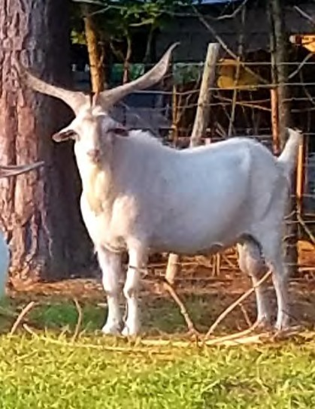
GOATEX 903/82 CAPRINEX 11/85
HELSINGTON 21/83

SIRE: GOATEX 62/89

DAM: SDR ELLA BERA NOTES:

GOATEX 214/84 GOATEX 614/86
GOATEX 2/84
BBM ONYX BEAR SDR NANOOK ONYX BEAR
SDR LOUISE BEAR
SKY S408 SPORTS KAT BBM SPORTS KAT V917
TLF ETOSHA

LOT 35 MYS MYSTIC HILLS KIKOS 100% NZ BUCK MYS WHITE LIGHTNING
NKR: N20M0012MYS9 TAG: 12 DNA: PV DOB: 1/25/20
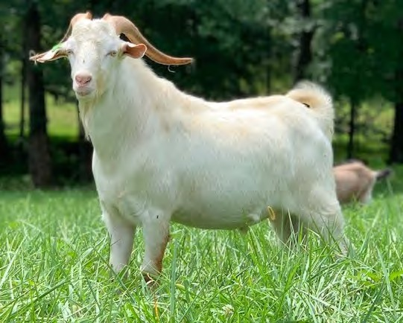
CGI RHETT 507

SIRE: CGI VAQUERO
CGI SHOGUN

TITAN’S LEIA
ECR CONDI
AKR LIGHTIN’S TITAN N06 CGI LEIA 504
GOATEX GOLIATH

WAYSU GOLIATH’S IMPRINT
GOATEX GESTURE

DAM: OLF RUBY TUESDAY
TAY ONYX

NOTES:
PRG ONYX’S LILY
GHK MULAN

LOT 36 LMY LINDA YORK 100% NZ BUCK LMY HOBO’S GUNPOWDER AND LEAD
NKR: N21M0217LMY9 TAG: 0217 DNA: PV DOB: 1/28/21
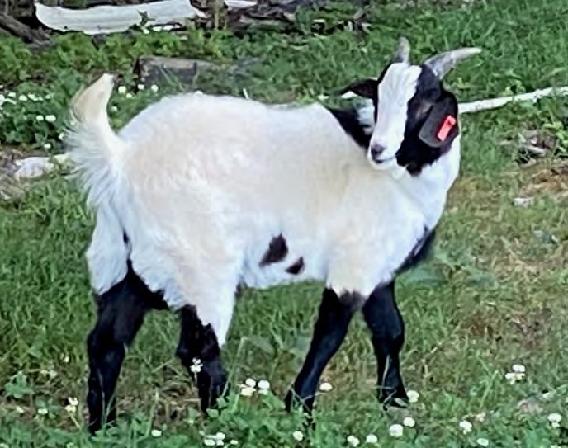
WMB HOBO HKF HOBO’S 276
HKF WILMOTENE

SIRE: WMC HOBO’S ROCKETMAN
HKF DANNY BOY

WMC CINNAMON
MEP WILD THANG

CVK KEEPERS E116 TMK E142 KEEPER’S SPORT
CLP RAGIN RIVERS DAISY

DAM: BMK BRIMAR JOLENE
CLP OUTTA THE BLUE

NOTES:
BMK MADONNA
SDR ANDREA BEAR

LOT 37 RLD RANDALL & LEA DANIELS 100% NZ DOE RLD JELLYPOP
NKR: N21F0264RLD TAG: 0264 DNA: PV DOB: 2/12/21
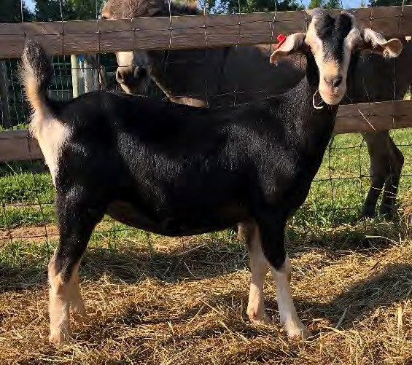
GHK WAY BEYOND THE BLUE RDH ONCE IN A BLUE MOON
RLP PEACHOCK’S WASH POT

SIRE: BKK BLUE KENTUCKY MOON
MCR ROCK SOLID

HSR LOVER BOY’S RED ROSE
AFS B119

BHR ZION

DAM: RRK BOOTS 43

NOTES:
BHR 132

BHR 135
TAY W.65 PRINCESS OREO OF Q FARMS BHR ZION
TAY W.36 PRINCESS SHANOAH OF Q FARMS

LOT 38 MYS MYSTIC HILLS KIKOS 100% NZ DOE MYS MYSTIC SCRATCH OF EDEN
NKR: N20F0015MYS1 TAG: 15 DNA: PV DOB: 1/25/20
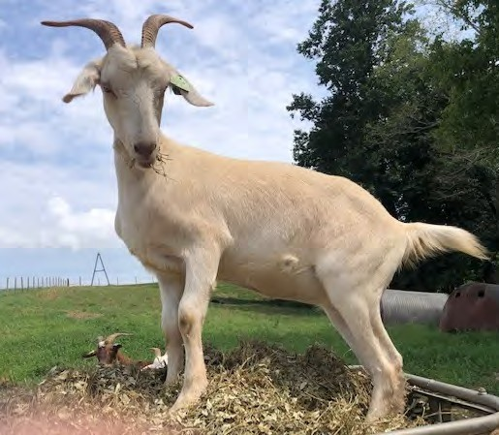
SOUTHWEST GOLDMINE’S ROCKER LRF PANGO HUA
TASMAN TOIA

SIRE: OLF SCRATCH

DAM: ITF LITTLE EDEN

GOATEX GENERATOR SDR GINA GENERATOR BEAR
SDR ALICE BEAR
GOLDMINE’S BLOCKBUSTER TSF GOLDMINE’S X354
GOLDMINE’S LITA
ECR RUSTY

NOTES:
ECR EDEN
ECR M2

LOT 39 WHF DAVID & DEBRA JOHNSON 100% NZ DOE WHF L10 REDBUD
NKR: N21F0010WHF5 TAG: L10 DNA: PV DOB: 2/18/2021
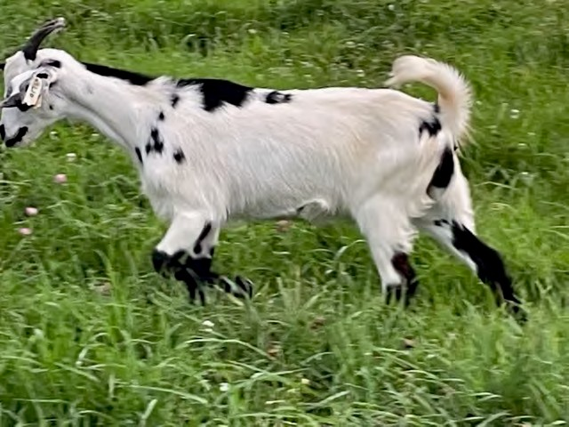
TAY ONYX GHK WINDY HILL ONYX STAR
GHK LITTLE BLACKIE

SIRE: WHF TRIPLE 8

WHF E57
WHF WINDY HILL ONYX STAR WHF C60 ELEANOR
GHK B79 BINGO

SPG 412 SCOTCH ON THE ROCKS
SDF SHARIDON’S DIDI

DAM: SPG 649 LIT’L LILLY
LAA GENERAL CUSTARD

NOTES:
SLS LIT’L CASSIE
JCP CASSANDRA

LOT 40 CWF WAYNE & CINDY FORSHEE 100% NZ DOE CWF VALERIE
NKR: N20F0158CWF0 TAG: 158 DNA: PV DOB: 2/26/2020
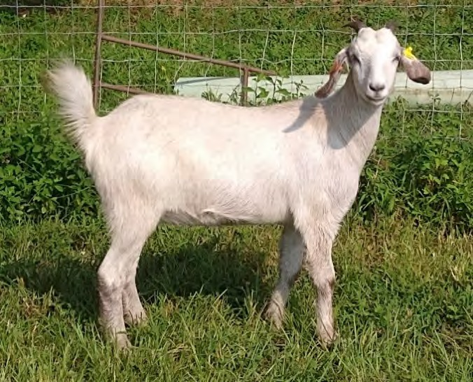
HKF SONNY BOY

MRG OUTLAW
SIRE: LFK OUTLAW’S FLASH G704
GHK A 59
HKF SAPHIRE COO IRON HORSE GHK Y51
SKY W018 WARSAW

DAM: SHO LORI F136
HKF BLACK PRICE “NICKSON”
HKF JEMIMA
TOF GOLD DUST

HKF LORI 228
HKF LO IV
NOTES: Vaccinated CDT and CL, confirmed bred to Outlaw's Flash.
LOT 41 ROW LESTER & STEPHANIE GOODMAN 100% NZ DOE ROW HONCHO’S FELICITY
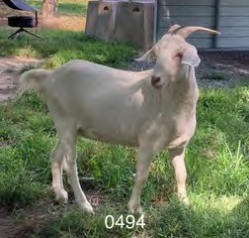
NKR: N20F0494ROW TAG:0494 DNA: PV DOB: 3/13/2
0
GOATEX GOLIATH WAYSU GOLIATH’S IMPRINT
GOATEX GESTURE

SIRE: OLF HONCHO’S KEEPER
TAY ONYX

PRG ONYX’S LILY
GHK MULAN

SDR STING BEAR

CWR DIESEL
DAM: CWR DIESEL’S VALENTINE
TUK COCOA

NOTES:
SDR CARLY ROSE BEAR
CLP RAGIN RIVERS STANGER CED LITTLE BEAR

LOT 42 ACK TRACY LOYD 100% NZ DOE ACK LAYLA
NKR: N21F0129ACK5 TAG: 0129 DNA: PV DOB: 1/17/21
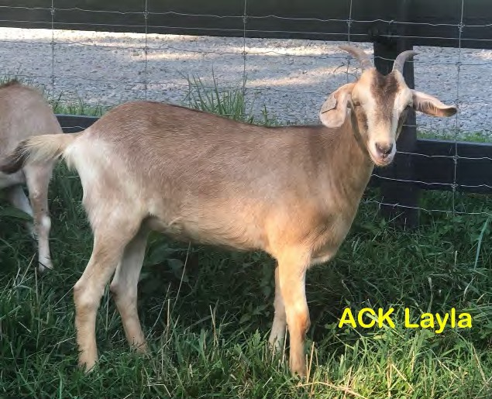
PJF HAMMER’S BIG JAKE PJF SUDDEN IMPACT (SI)
SKY 1108 LINDSEY

SIRE: ACK DENALI
ACK SEVEN

DAM: ACK LACY
GNX ROSCOE KIKOTRAIN SMK RUBY
GNX ACE GNX ROSCOE KIKOTRAIN
GHK LOUISIANNA
SMK IRON FRED

SMK LULU
TOF CATY
NOTES: Layla’s dam is out of another top cross in my herd. Layla is t he first doe I’ve sold out of ACK Denali, sire of the 2nd place buck in the 2020 WV buck test.

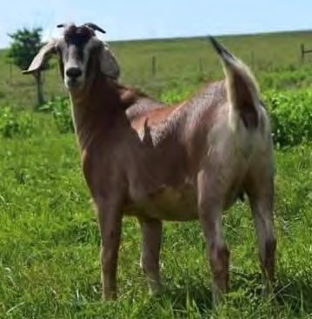LOT 43 KDJ KENNETH & CONNIE JESSEE 100% NZ DOE KDJ TOMAHAWK’S MISTY
NKR: N20F2017KDJ1 TAG: 2017
MRG OUTLAW
DNA: PV
DOB: 1/1/2020
HKF SONNY BOY
HFK SAPHIRE SIRE: LFK H809 OUTLAW’S TOMAHAWK
COO IRON HORSE
GHK A 59
GHK Y51
ELH BLUE BOY 1L ELH BLUE’S SON
ELH 7L
DAM: BWP BLUES SON MISTY
GFI ROLLING MEADOWS 81 BWP SPECKLES BUTTERCUP
DSW W3 BESSIE

NOTES: Tomahawks Misty is a big, bold daughter of BWP Blue’s Son Misty. Also she is a full sister to the high selling doe at the BPI sale.

LOT 44 LRF JOHN ROLLER 100% NZ DOE LRF 1622’S OGO KAT
NKR: N20F0128LRF7 TAG: 0128 DNA: PV DOB: 1/12/20
SKY W018 WARSAW HKF SONNY BOY
HKF SARA RUTH

SIRE: SAN SONNY BOY’S 1622
GIN V2C
TNT CODY
OAK VALLEY 0053 MRG OUTLAW

RDH OUTLAW’S GOLDMINE
TSF LITA’S GIRL

DAM: LRF OUTLAW’S LADY
LRF GLORIA

NOTES:
TLF TOP GUN WMB EMILY

LOT 45 DBC JUDY CARTER 100% NZ DOE DBC DOUBLE C’S ADELITA
NKR: N19F0306DBC3 TAG: 306 DNA: PV DOB: 3/6/19
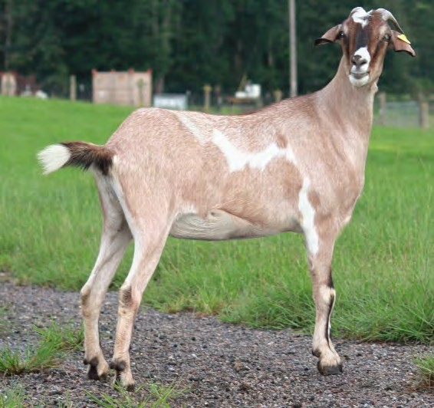
CAPRINEX SAMUEL HESLINGTON SESAME
CAPRINEX 964/84

SIRE: OLF HIDALGO

HESLINGTON STING SDR LONG TALL SALLY
SDR PIPER BEAR
LRF PANGO HUA

DAM: SHO C199
WMB HOBO
ECR CONDI
AVG MAXIMILION

SHO POLLIEANNA
DSW GOLIATH SWEETS W20

LOT 46 PRG RICH OR LAURA DAVIS 100% NZ DOE PRG RAVENCLAW
NKR: N18F0045PRG0 TAG: 45 DNA: PV DOB: 1/27/18
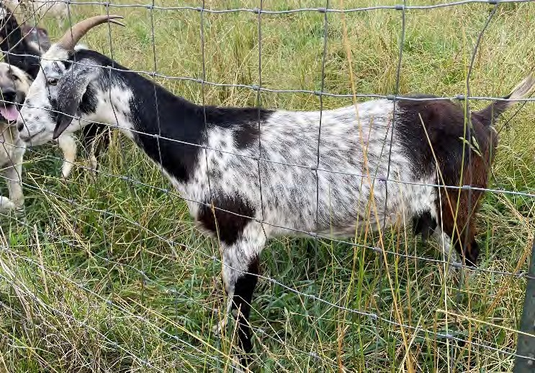
ARAOA ARISTOCRAT TASMANS ARISTOCRAT
BARDON BEAUTIFUL

SIRE: JFK NOBLE

GOATEX TERMINATOR SOUTHWEST JOCELYN
GOATEX JOVENDA
GOATEX GOLIATH WAYSU GOLIATH’S KEEPER
GOATEX GESTURE

DAM: FDL KEEPERS BELLE D7
CPK HOSS

NOTES:
LAF CONSTANCE
TNB LIBERTY

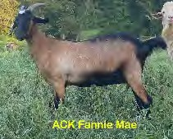LOT 47 ACK TRACY LOYD 100% NZ DOE ACK FANNIE MAE
NKR: N20F0087ACK6
TAG: 0087 DNA: PV
DOB: 1/2/20
GFI WILD BILL
GNX ACE
SIRE: GNX ROSCOE KIKOTRAIN
BOULDER HILLS WR179
COO IRON HORSE
GHK LOUISIANNA
TAY W.48
DAM: TMK E102
BLUE’S SON CLP OUTTA THE BLUE
SDR DENNA BEAR
GHK APACHE LOVERBOY
TMK D59
GAL CHAMPAIGN

NOTES: Fannie has been tough as nails since birth, plus she has a nice long frame to carry kids. Her dam has great maternals.

LOT 48 NNT GRANVILLE & MARY CHEATHAM 100% NZ DOE NNT K2055
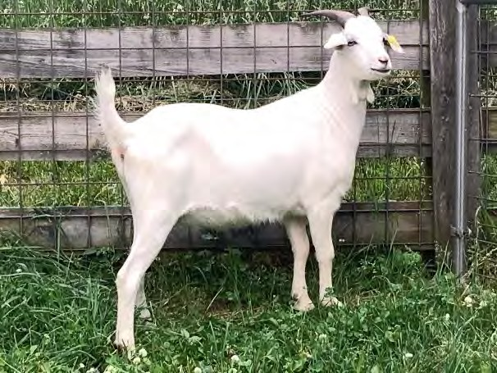
NKR: N20F2055NNT7 TAG: K2055 DNA: PV DOB: 3/8/2020
SLR TERMINATOR’S XX

GFI HEMI
SIRE: MRG HEMI’S WORTHINGTON
TAY 23
WAYSU GOLIATH’S KEEPER

BWP KEEPER’S LOLA
TNB #61

TLF TOP GUN

DAM: NNT H1874
LCK REDMAN

NNT F609
ECR VICTORIA’S SECRET ECR ALEXANDER
BBM SPORTS KAT V890

NOTES: Dual registered with the AKGA, CD&T vaccinated, tested negative for CAE & Johnes'

LOT 49 GSK DARRYL BYRD 100% NZ DOE GSK BLUE ANGELA
NKR: N20F0652GSK TAG: 0652 DNA: PV DOB: 1/14/20
ECR RUSTY

SIRE: CGI CROSSFIRE
CGI SPITFIRE

EGI ESTHER
HRK PANGO’S SUMMER BREEZE LRF PANGO HUA
CGI BARON’S DELIGHT
BLUE’S SON

GHK GEORGIA BLUE’S SON
GHK LITTLE BLACKIE

DAM: TSF BLUE’S ANGELA
BWP 119 KANE’S THUNDER

NOTES:
MVH KANE’S ANGELA
JFK ANGELA’S KAY

LOT 50 MYS MYSTIC HILLS KIKOS 100% NZ DOE OLF SCRATCH
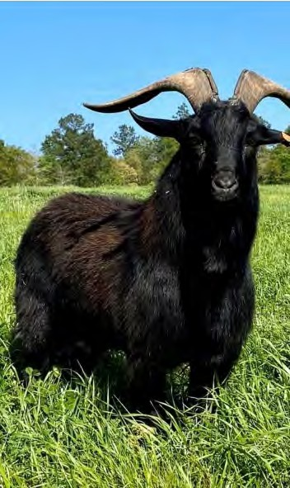
NKR: N17M0098OLF3 DOB: 1/13/17 TWO FROZEN SEMEN STRAWS
AAS GOLDMINE IV SOUTHWEST GOLDMINE’S ROCKER
BARDON AGNOSTURA

SIRE: LRF PANGO HUA
TASMAN TOIA
ARAROA ARISTOCRAT
TASMAN MEDELINE GOATEX SINATRA

GOATEX GENERATOR
GOATEX 159/90

DAM: SDR GINA GENERATOR BEAR
BBY ONYX BEAR

NOTES:
SDR ALICE BEAR
TNT’S 0218

LOT 51 JAH JOSHUA HEADDEN 100% NZ BUCK TNT’S RAIZ’N’KANE
NKR: N04M0065TNT3 TAG: DOB: 3/14/04 TWO STRAWS OF FROZEN SEMEN
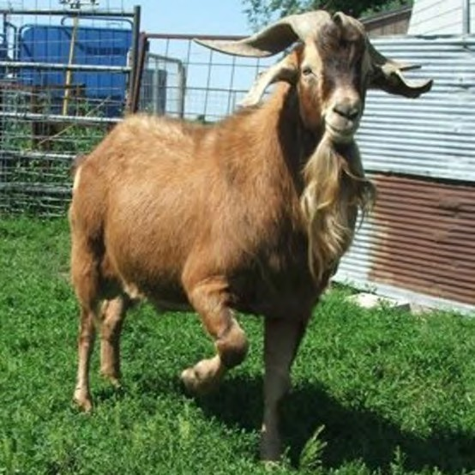
BETULA HILL BOUNCER BETULA HILL MONEYMAKER
BARDON 62/84

SIRE: SUNBOY 117 LOVERBOY
ARAROA ARISTOCRAT

SEVENTREES SANDALWOOD
SET 116

JTV ALADIN

DAM: JTV L2
JTV STALONE
GOATTEX GOSSAMER GOATEX SINATRA

NOTES:
GOATEX CAPRICE
GOATEX 161/91

LOT 52 ROW LESTER & STEPHANIE GOODMAN 100% NZ BUCK SPK SUNBOY ROTAN 150
NKR: 7P150SPK4 TAG: DOB: 3/29/97 TWO STRAWS OF FROZEN SEMEN
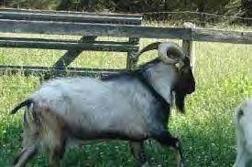
GOATEX FORMIDABLE BETULA HILL BOUNCER
BARDON 31/84

SIRE: BETULA HILL MONEYMAKER
BAR 482

DAM: SUNKIST #21 NOTES:
BARDON 62/84
BAR 800
GOATEX SINATRA GOATEX GENERATOR
GOATEX 159/90
ARAROA ARISTOCRAT SEVENTREES SANDALWOOD
SET 116

LOT 53 PRG RICH OR LAURA DAVIS 100% NZ BUCK PRG MR BLUE SKY
NKR: N20M0109PRG9 TAG: K109 DNA: PV DOB: 4/49/20
ELH BLUE BOY 1L
BLUE’S SON
ELH 7L
SIRE: CLP PALE RIDER
BBM ONYX BEAR
SDR DENNA BEAR
SDR DANITA BEAR

ECR KATMANDU AMM TOP CAT
TLF EBONEE

DAM: AMM MISS DAPPLE
ECR KATMANDU

AMM DANIELLE B
POK DANIELLE
NOTES: from an embryo flush; PRG’s top weaning buck of 2020
LOT 54 PRG RICH OR LAURA DAVIS 100% NZ DOE PRG J4 MALLORY
NKR: N19F0004PRG5 TAG: J4 DNA: PV DOB: 1/5/19
BETULA HILL MONEYMAKER SUNBOY 117 LOVERBOY
SEVENTREES SANDALWOOD

SIRE: PRG LOVERBOY’S MOJO JOJO
GHK SARABI
COO IRON HORSE
AKR LIGHTIN’S LADY N13 BLUE’S SON

PRG MIDNIGHT SKY
GHK VENUS

DAM: PRG MIDNIGHT’S MAY
CGI APRIL
NOTES:
LRF PANGO HUA AVG JUNE

LOT 55 LMY LINDA YORK 100% NZ DOE LMY POSIDEON’S BEARY FRECKLES
NKR: N20F0202LMY4 TAG: 0202 DNA: PV DOB: 9/11/20
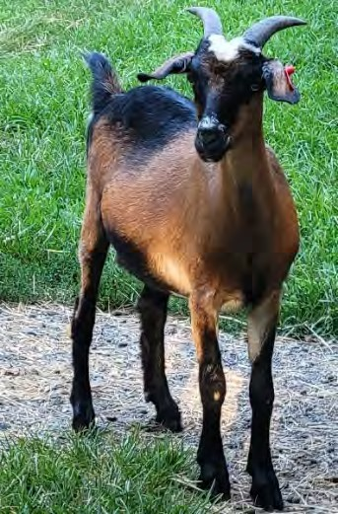
CAPRINEX SAMUEL HESLINGTON SESAME
*4K984CPR

SIRE: SDR POSIDEON SESAME BEAR
BBM ONYX BEAR

DAM: KOK TIFFANY NOTES:
SDR ROSEMARY BEAR
BBM SPORT’S KAT RILEY
SAF SPRING’S MERLIN SAF SPRING’S ST NICK
LGB ASPEN 152
BBM SPORTS KAT’S W147 RMS SPRINGTIME
KMG DELIA

LOT 56 KDJ KENNETH & CONNIE JESSEE 100% NZ DOE KDJ TOMAHAWK’S SPECIAL
NKR: N20F2013KDJ5 TAG: 2013 DNA: PV DOB: 1/1/2020
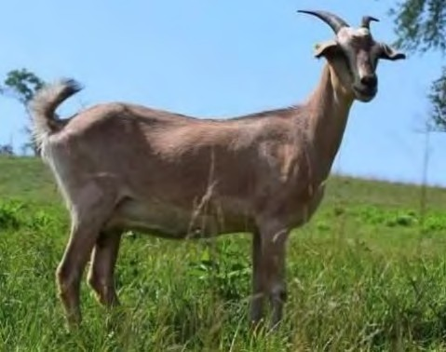
HKF SONNY BOY

MRG OUTLAW
HFK SAPHIRE

SIRE: LFK H809 OUTLAW’S TOMAHAWK
COO IRON HORSE

GHK A 59
GHK Y51
COO IRON HORSE

GHK B79 BINGO
GHK LITTLE BLACKIE

DAM: SPG 352 NADINE
HVF CAPTIAN RED

HVF 1076 FLASH
HVF 1009
NOTES: Tomahawk’s Special is a daughter of SPG 352 Nadine a full sister to Sundance Kid
LOT 57 MYS MYSTIC HILLS KIKOS 100% NZ DOE MYS MYSTIC BLONDE 1
NKR: N20F0010MYS1 TAG: 10 DNA: PV DOB: 1/25/20
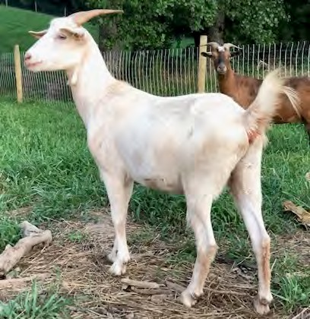
ECR RUSTY

SIRE: CGI DEUCE
CGI SPITFIRE

CGI ESTHER
HRK PANGO’S SUMMER BREEZE LRF PANGO HUA
CGI BARON’S DELIGHT
ECR RUSTY

DAM: OLF LODI
ECR RUSTY’S RAMBO
ECR HANKY PANKY
ECR RUSTY

NOTES:
ECR SUNNY
ECR M4

LOT 58 WPK ANDY & PAIGE ROLLER 100% NZ DOE `WPK 1622’S ESTHER DREAM
NKR: N20F0133WPK8 TAG: 0133 DNA: PV DOB: 1/16/20
SKY W018 WARSAW HKF SONNY BOY
HKF SARA RUTH

SIRE: SAN SONNY BOY’S 1622
GIN V2C

CGI ZORBA DAM: CGI ESTHER’S DREAM Y579
CGI ESTHER
NOTES:
TNT CODY
OAK VALLEY 0053 WMB XAVIER
CGI ESTHER
LRF PANGO HUA
CGI BARON’S DELIGHT

LOT 59 RLD RANDALL & LEA DANIELS 100% NZ DOE RLD HOPE
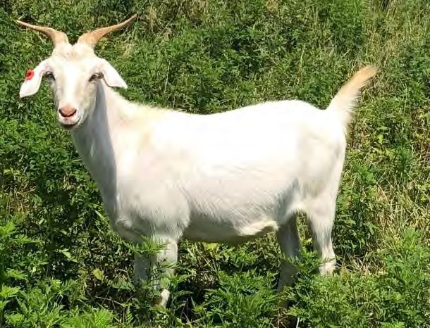
NKR: N19F0209RLD2 TAG: 0209 DNA: PV DOB: 12/1/19
SOUTHWEST SPORTSMAN LRF W-304 SUPERSPORT
FIVE C CHANTELLE

SIRE: MRG SUPERSPORT’S 1340
GFI HEMI

MRG GEORGIA BELLE
GFI GEORGIA

HELSINGTON SESAME SDR CALL ME SESAME BEAR
SDR ROSEMARY BEAR

DAM: CWR SESAME’S JENNY
CVK APOLLOS A22

NOTES:
BWP APOLLOS 569 GIRL
BWP KANE’S 48 GIRL

LOT 60 ACK TRACY LOYD 100% NZ DOE ACK AUTUMN
NKR: N21F0138ACK2 TAG: 0138 DNA: PV DOB: 1/20/21
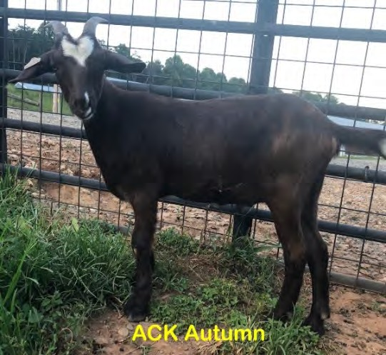
GFI WILD BILL

GNX ACE
SIRE: GNX ROSCOE KIKOTRAIN
BOULDER HILLS WR179 COO IRON HORSE

DAM: TMK E102
GHK LOUISIANNA
TAY W.48
BLUE’S SON CLP OUTTA THE BLUE
SDR DENNA BEAR
GHK APACHE LOVERBOY

TMK D59
GAL CHAMPAIGN

NOTES:I have her full sister retained in my herd. Her full sister kidded unassisted as a first timer and was a natural as a mother. I would expect the same from Autumn. She is a very well built doeling.

LOT 61 DBC JUDY CARTER 100% NZ DOE DBC TOPAZ
NKR: N19F0315DBC0 TAG: 315 DNA: PV DOB: 3/11/19
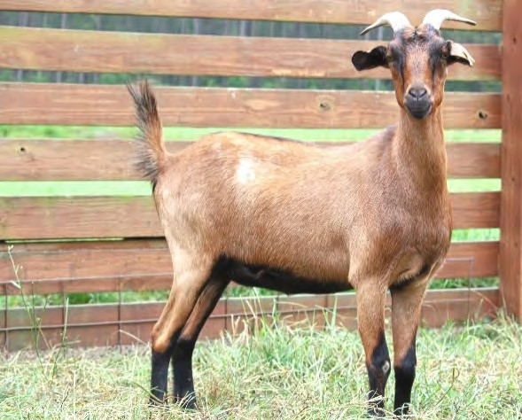
SOUTHWEST GOLDMINE’S ROCKE LRF PANGO HUA
R
TASMAN TOIA

SIRE: OLF SCRATCH

GOATEX GENERATOR SDR GINA GENERATOR BEAR
SDR ALICE BEAR
TAY ONYX COO IRON HORSE
AFK NIKI

DAM: GHK IRON HORSE’S CREAMY
AVG MARTHA
NOTES:
TAY M22 BHF ALICE

LOT 62 CWF WAYNE & CINDY FORSHEE 100% NZ DOE CWF TAMMY
NKR: N20F0162CWF7 TAG: 162 DNA: PV DOB: 3/9/2020
LRF PANGO HUA
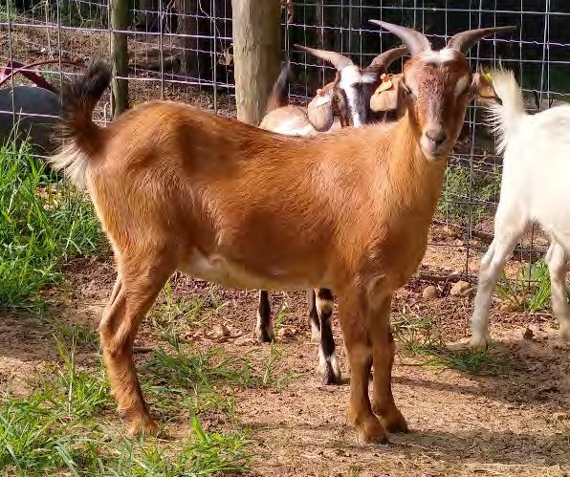
WMB HOBO
ECR CONDI
SIRE: HKF HOBO’S PRIDE
CPK LITTLE JOE
HKF TRIG’S GIRL
HKF TRIG

CLP RAGIN RIVER’S BAMBER

DAM: CWF WILMA
JTF BAMBER 2

WJB 90
SAF SPRING’S MERLIN’S PANDOR SDR BEETHOVEN BEAR
WJB 52
A

NOTES: Vaccinated CDT and CL, confirmed bred to Outlaw's Flash.

LOT 63 GSK DARRYL BYRD 100% NZ DOE GSK STELLA
NKR: N20F0654GSK TAG: 0654 DNA: PV DOB: 1/24/20
ECR RUSTY

SIRE: CGI CROSSFIRE
CGI SPITFIRE

EGI ESTHER
HRK PANGO’S SUMMER BREEZE LRF PANGO HUA
CGI BARON’S DELIGHT
MRG OUTLAW

LFK OUTLAW’S IRONMAN
GHK A59

DAM: GSK LADY MOCHA
GSK A635
NOTES:
SKY 215 XCLUSIVELY BLUE DSW X32 SHARIDON’S APRIL

LOT 64 NNT GRANVILLE & MARY CHEATHAM 100% NZ DOE NNT K2070
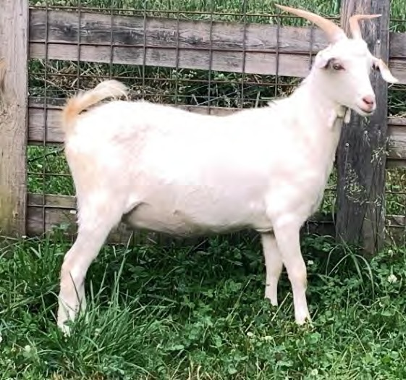
NKR: N20F2070NNT9 TAG: K2070 DNA: PV DOB: 3/8/2020
SOUTHWEST SPORTSMAN SKY S408 SPORTS KAT
TASMAN TEMPTRESS

SIRE: CLP RAGIN RIVER’S HITMAN
TSF ZOLO’S R090

DAM: NNT F685
TSF ZOLO’S R479
ECR RED NELLE
BBM ONYX BEAR SDR PIERS BEAR
ECR PETUNIA
MMG MIDDLEBROOK MAGIC

NNT A50
NNT’S Y10

NOTES: Dual registered with the AKGA, CD&T vaccinated, tested negative for CAE & Johnes'

LOT 65 MWS MARION L & WANDA D SIMPSON 100% NZ DOE MWS NICKY
NKR: N18F0213MWS5 TAG: 0213 DNA: PV DOB: 2/18/2018
GOATEX GENERATOR GHK HIGH VOLTAGE
MRG LIGHTIN’S LADY R06

SIRE: AAA REGULATOR
WAYSU’S GOLIATH’S KEEPER

GHI ROLLING MEADOWS 198
GFI CONFEDERATE/ZORRO 19

AKR LIGHTIN’S TITAN N06 MRG TITAN’S HAMMER
AKR LIGHTIN’S LADY N08

DAM: GAL SAMANTHA
JFK ELLY

NOTES: Has Regulator’s blue eyes.
TASMAN ARISTOCRAT WAYSU’S GOLIATH’S ELEGANCE

LOT 66 JPRG RICH OR LAURA DAVIS PB DOE PRG K213
NKR: N20F0213PRG9 TAG: K212 DNA: PV DOB: 11/20/20
LFK OUTLAW’S RENEGADE YFK RENEGADE’S STORMY
HKF LITTLE JOE’S JOSEPHINE

SIRE: SAF SPRINGS DIEGO
TMK MACHO’S BLACK GUY

SAF SPRINGS CALICO PATCH
TJR SUNSHINE

KMG MARKSMAN

DAM: CFP HEATHER NOTES:
JDR OLIVER

JDR HILLARY
KMG ASTRA
BBM NICK’S W948 JDR JAZY’S GIRL

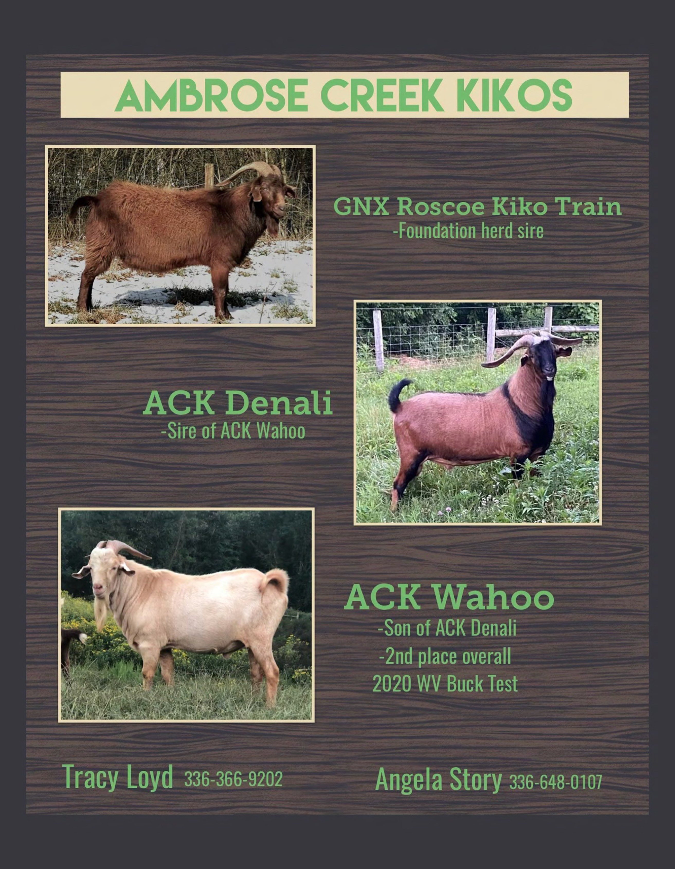

Rich and Laura Davis in Carrollton, GA

Welcomes two new herd sires

PRG Leatherneck
Grandson of Sting and Keeper

PRG Langston
Direct son of ECR Rusty

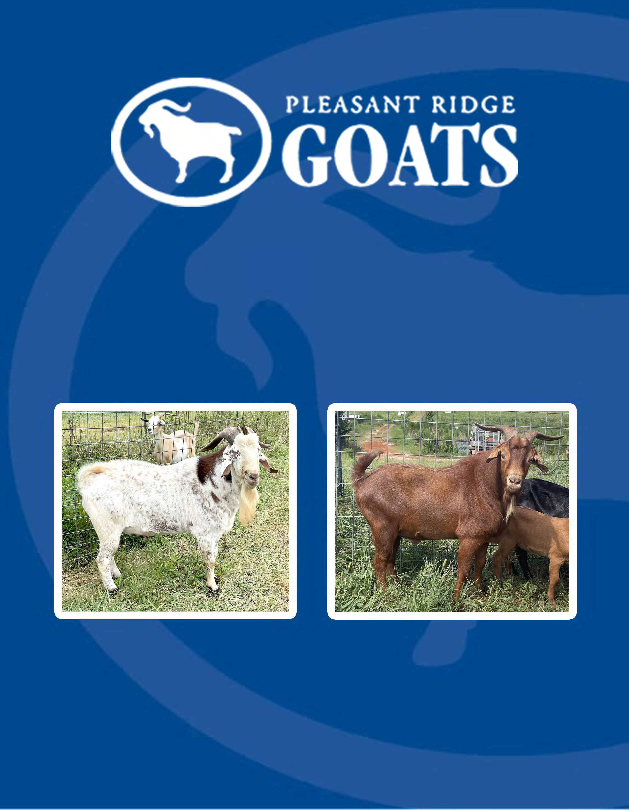

www.pleasantridgegoats.com

The National Kiko Registry would like
to welcome you to the
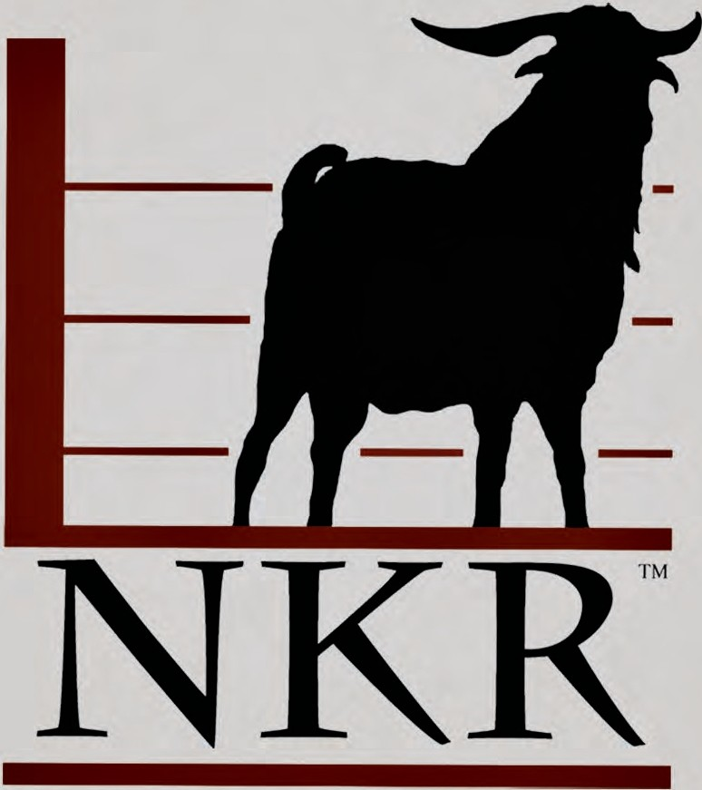

To learn more about how NKR can benefit your meat goat operation, visit our website or give Karen a call.
www.NationalKikoRegistry.com
Karen Brown, registrar • 770-844-4300 • nkr.reg@gmail.com
NKR, POB 1800, Cumming GA 30028
The National Kiko Registry...Thinking outside the fence

